**Southampton Mental Health Support Team**

**Secondary Schools/Colleges Wellbeing Newsletter**

**Summer Holiday Edition 10th July 2020**

Welcome to our last newsletter before the summer holidays.

**The MHST is operational 52 weeks of the year, therefore our service continues to be open during the summer holidays and we continue to welcome referrals from parents/carers, young people and schools.**

**If you would like a referral form please email** [**SouthamptonMHST@solent.nhs.uk**](mailto:SouthamptonMHST@solent.nhs.uk) **. We can send the referral form by email or by post.**

Life is becoming busier again with schools and businesses gradually reopening but access to services still harder than usual. We are also coming to the end of the school year in strange and different circumstances without the usual opportunities to celebrate our achievements or say goodbye to people if we, or they, are moving on. This can bring with it feelings of sadness.

It is really important that we make sure that we are planning in time and activities which refresh us and bring a sense of balance and wellbeing in our lives. Finding balance is vital for our mental health and wellbeing; our happiness. It is important for us to realise that we have the power to make small changes in our lives to take control of this balance for self-care and wellbeing. We need to feel that we have a good mix of work, relaxation, exercise and getting important jobs done so that we can feel on top of things, healthy and happy.

It is also important to stay connected with our friends and wider family. In life, there are always so many jobs to do: the washing; tidying up; seeing friends and family that you haven’t seen for ages; getting to the shops; school or work…all these things are important. In our newsletter this week, however, we want you to think about planning in things which make us stop and be still and do something just for ourselves, or do nothing at all…just rest.

What self-care looks like will be different for each of us. We will give some suggestions to help you consider what sorts of activities help you to find balance in the busyness of life.

Below are some tips for self-care to help you feel happier, more in control and better able to cope with life’s challenges:-

• Enjoy yourself – simple activities, such as meeting up with friends, reading a good book, having a soak in the bath can make you feel happier and improve your day. Starting a new project you’ve been intending to do or participating in hobbies you enjoy and are good at, such as sport or cooking will add a sense of achievement which can give a real boost to your self-esteem.

• Stay in the here and now – focussing on possible difficulties or problems in the future can increase anxiety. Be selective about news and social media by using reliable and trusted sources and limit your exposure to checking it once or twice a day. Participate in things that will lift and calm your mood, such as practicing yoga or other relaxation methods as well as listening to upbeat or calming music. Listening to podcasts, such as ‘Happy Place’ by Fearne Cotton could be a useful way to unwind <https://open.spotify.com/show/1J6Ddy4dcXjFZDmWQs3Pu0>

• Be kind to yourself and others – treat yourself in the same way you’d treat a valued friend. Notice if/when you put yourself down and tell yourself something positive instead. Challenge your negative thoughts. If you are working from home communicate about when you have important calls and meetings. Be kind and tolerant of others in your household who are working from home if you are sharing space.

Lead a healthy lifestyle – there are a number of factors which contribute to leading a healthy lifestyle:-

(vii) Eat a healthy, well balanced diet – aim to include all the main food groups as this will help your brain and body work efficiently <https://www.nhs.uk/live-well/eat-well/the-eatwell-guide/>

(viii) Exercise regularly – chemicals will be released in your brain when you exercise which will lift your mood, give you more energy, help you sleep better and keep your heart healthy <https://www.nhs.uk/conditions/stress-anxiety-depression/exercise-for-depression/>

(ix) Get enough sleep – we need around 7 to 8 hours of good quality, uninterrupted sleep to allow our body and mind to fully rest and enable us to function properly and boost wellbeing. Lack of sleep can contribute to fatigue, irritability and lack of focus as well as depression and anxiety <https://www.nhs.uk/live-well/sleep-and-tiredness/how-to-get-to-sleep/>

(x) Manage your stress levels – introduce positive changes to help you reduce stress in your life, such as taking time out for yourself. Breathing techniques can also help when you are particularly stressed. <https://www.nhs.uk/conditions/stress-anxiety-depression/ways-relieve-stress>

(xi) Limit your alcohol intake – it can be tempting to drink alcohol when you feel stressed and anxious, but in doing so the feelings you are experiencing may become exaggerated, so you may feel more stressed, anxious, depressed or angry <https://www.nhs.uk/live-well/alcohol-support/tips-on-cutting-down-alcohol/>

**Parents Top Tips**

**Good News Story 1**

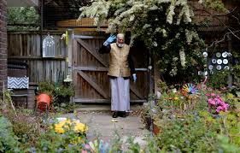



Inspired by Captain Tom Moore, this equally inspiring 100 year old, Dabirul Choudary from St Albans, has raised over £218, 000 by walking laps of his garden. To add to the challenge, Dabirul completed this feat during the fasting month of Ramadan, the Islamic holy month. The money raised is going to support Coronovirus victims both in the UK and in Bangladesh.

See the story on ITV News: <https://www.youtube.com/watch?v=cCgIdtFIpFk>

(xii) Maintain contact and communicate with others – it is important to stay connected to others as this can reduce feelings of isolation and anxiety. However, with lockdown rules now easing, some can feel pressure to keep saying yes to meet up with others. Do what feels right for you and give yourself permission to say no if you feel you are becoming overwhelmed. If you do feel overwhelmed, talking things through with a friend or family member can help to release tension, rather than keeping feelings “bottled up” inside. Talking to a counsellor/therapist can also be very helpful <https://www.nhs.uk/conditions/stress-anxiety-depression/benefits-of-talking-therapy/>

• Keep to a routine – wake up and go to bed at the same time every day. Keep consistent meal times.

• Make a schedule – schedule things you need to do each day; include meetings and work commitments as well as rest breaks and spending time with your young person. Have a defined beginning and end to the working day. This can reduce anxiety by allowing you to set expectations and bring a sense of control.

• Have clear boundaries – you could create a stop light system for your office space. Red indicates you’re busy and cannot be disturbed – green means you’re free and available.

**Parents Top Tips continued**

We spend a lot of time talking about ways to make us happier, maintain

close friendships, look on the bright side and drink more water.

But we don't often think about how we 'feel' happiness.

Did you know the warmth you feel from a hug is caused by entirely different chemical sensation then the high you feel from a long run or bike ride?

There are 4 main brain chemicals that can drive the positive emotions you feel throughout the day:

**Serotonin** - another social chemical. We experience the effects of Serotonin when we receive recognition from others or a sense of accomplishment. This has an impact on our mood.

**Dopamine** - it helps you to get through your to do list or motivates you to start a new habit. Dopamine causes that 'little happy' feeling when someone likes your post on social media or someone says 'you look nice today'.

**Oxytocin** - affectionately referred to as the 'hugging drug', it is released from the brain during physical contact. You can increase your oxytocin levels by having positive social interactions for example sharing a meal.

**Endorphins** - essentially released in response to pain, they help us push our bodies beyond their comfort and persist when otherwise we might want to give up. Endorphins are the reason exercise is often suggested to help with stress.

Each of these chemicals play a huge part in the way our bodies function physically, mentally and emotionally.

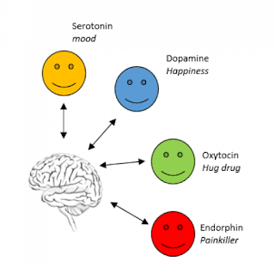

**Professor Wellbrain**

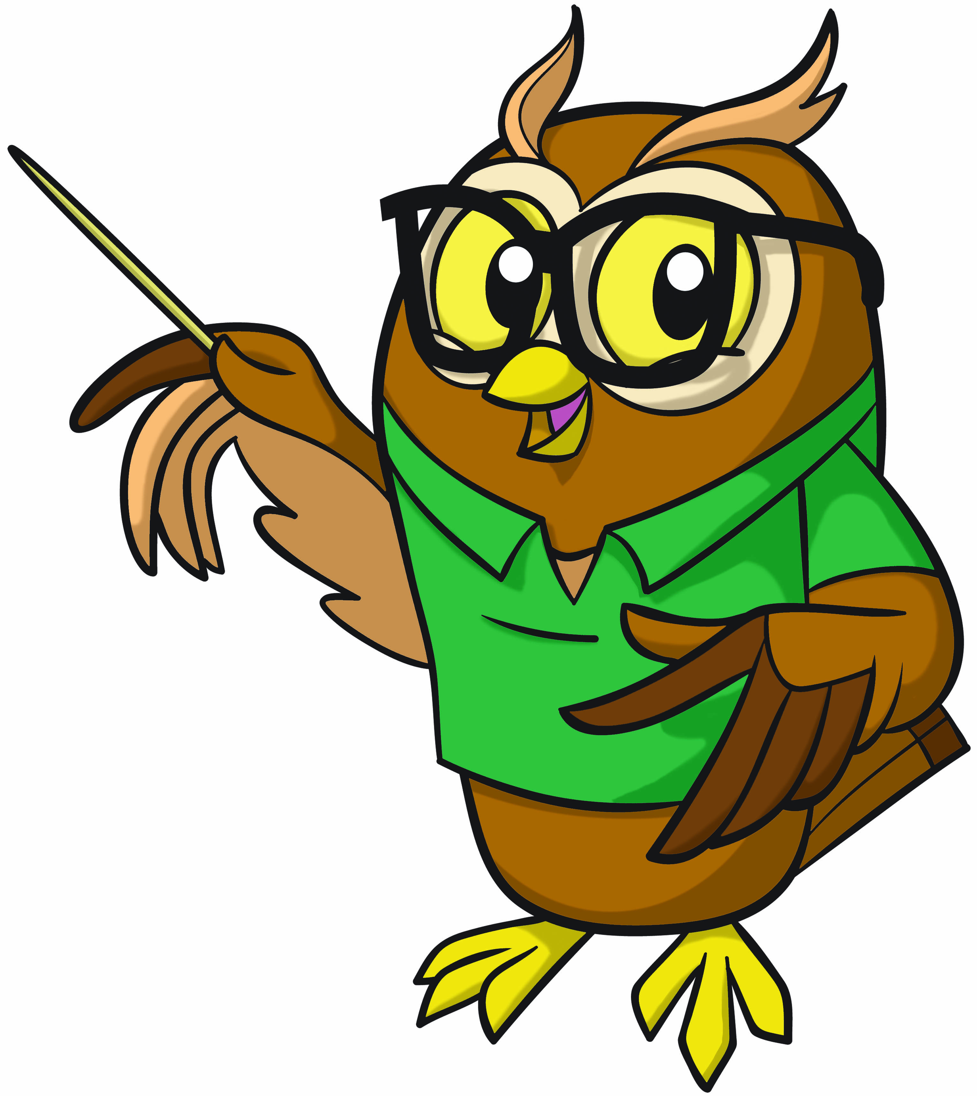

**Activity 1 – Self-Care Technique for Inner Peace**

If you find yourself upset by the frustrations of day-to-day life, try this simple breath-counting exercise. Counting backward increases your concentration, which focuses your distracted mind.

1. Gently closing your mouth & breathing through your nose, breathe in for a count of 4, and then breathe out for a count of 4.
2. Repeat but counting backward – breathe in 3, 2, 1, breathe out, 3, 2, 1. Take at least 10 deep breaths in & out, then decide whether you need to take 10 more.
3. As your breath begins to slow down, notice what happens to your emotions – do you feel calmer or less bothered? Watch what is happening to your body, - are your shoulders & neck muscles relaxing or your fists uncurling?

Don’t worry if you do not see immediate results when you start using this technique. Remember that your emotional well-being is a continual process of growth, breath by breath.

Warning: If you are prone to any respiratory conditions such as Asthma, please take breaths which are manageable for you and do not hold your breath. You could reduce the intake of breaths to 5 in stage 2. If you are in doubt seek medical advice from your GP first before trying this technique.

**Football Giving Back**

Matt le Tisser and Iwan Thomas have been working closely with the club’s charitable arm “the saint’s foundation” throughout the coronavirus pandemic. Both Matt le Tisser and Iwan Thomas have been helping out down at FareShare with the staff of Saints Foundation, packing and delivering food to those most vulnerable due to the current pandemic.

Matt Le Tisser stated: “It was a really eye-opening experience for me. To see all of the food being taken out into the community showed me how much projects like this are needed at the moment. What the club and the community are currently doing is a real inspiration.”

<https://www.southamptonfc.com/news/2020-04-09/ex-saints-step-up-to-volunteer-with-saints-foundation>

<https://www.dailyecho.co.uk/sport/18548174.matt-le-tissier-iwan-thomas-named-saints-foundation-ambassadors/>



**Good News Story 2**

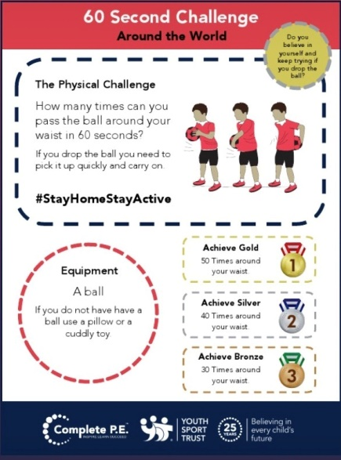

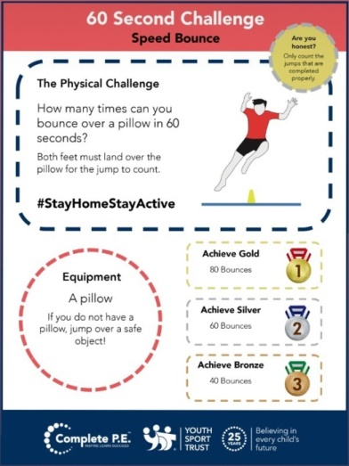

**Activity 3 – 60 Second Challenges**

**Activity 2 – Doing Good Makes You Feel Good**

We love these 60 second speed challenges, all of which can be done inside, with equipment you already have. These can be made into a competition with other family members, remotely with friends or personal competitions where you try to beat your own score.

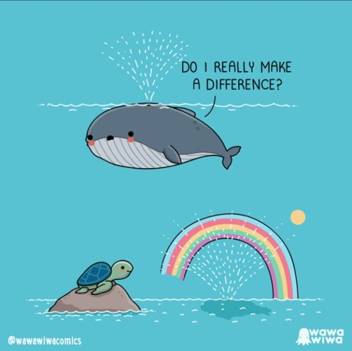

You may recognise the expression “it is better to give than receive”, but did you know this is backed up by research?

People who are kind and compassionate see clear benefits to their wellbeing and happiness. Kindness can also help reduce stress and improve our emotional wellbeing.

Setting ourselves an achievable challenge can be a positive experience as well as lift our mood.

Linking in with the Good News Story of Matt Le Tisser and Iwan Thomas what about setting yourself a challenge this week to carry out 2 acts of kindness:

Examples:

* Make your bed
* Text a friend “asking how they are”
* Wash up after dinner
* Make a family member/carer a drink
* Draw a picture and stick it on your window

for others to enjoy.

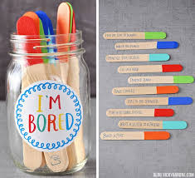

This year’s summer holidays are likely to be different from the usual; it might feel like you have already done all the activities you can think of.

Why not spend some time making an “I’m Bored” jar; a place where you can store lots of activity ideas, try and include as many free and low cost ideas as you can to make it easier to do the activity when you are feeling bored. Here is an example list: <https://www.muminthemadhouse.com/wp-content/uploads/2014/07/Ultimate-bored-jar.pdf>

However you can also add and create your own (Google also has lots of ideas).

**Activity 5 – I’m Bored Jar**



This recipe from Change for Life looks super yum and only uses one ingredient. For more recipes which you can make visit: <https://www.nhs.uk/change4life/recipes>

Ingredient: Very ripe banana (1 per person)

Method:

1: Peel and slice the bananas – use 1 banana per person.

2: Freeze for at least 2 hours, or overnight.

3: Add to a food processor and blend until smooth and creamy. Scoop into bowls and tuck in!

For an extra twist, add a sprinkle of cinnamon or a handful of frozen fruit.

**Activity 4 – Easy Banana Ice Cream**

Having a self-care routine is important for our physical and mental health. Every one’s self-care routine will look a bit different. Our daily routines consist of activities which are necessary, routine and pleasurable. During Covid and lockdown many of us have been feeling low and lethargic and may not have been taking care of ourselves as well as before lockdown. When we feel low or lack motivation sometimes it can be difficult for us to remember what we used to do and enjoy before we were feeling this way. Giving yourself some time to focus on some self-care can have a positive effect on your mood. A bit of pampering is not only good for your skin or hair but great for your mental health.

There are homemade remedies which are easy to make and affordable, plus you may find all the ingredients in the kitchen cupboard meaning a trip to the shops is not needed.

Below are some suggestions you may like to have a go at making and build into your self-care routine. With all the extra hand washing we have had to do try out this;

**Soothing Hand Mask:**

1 teaspoon almond oil (olive, coconut or vegetable oil can be used)

1 teaspoon honey

Optional 2 drops of Lavender essential oil (or camomile if preferred) oil (these are good for soothing the skin)

Mix the ingredients and massage into freshly washed damp hands. Relax for 15 minutes, then rinse the hands with warm water and apply a moisturiser.

**Try this anti-inflammatory face mask:**

1 teaspoon unflavoured plain yogurt

1 teaspoon honey

Mix ingredients all together until they create a consistent mixture. Scoop some of the mixture onto your fingertips, gently massage all over your face making sure to avoid your eye area. Leave this on for around 10-15 minutes before washing it off with cool water.

A good tip is to keep a note of what treatments you enjoy and helps you feel relaxed so you can use these pleasurable activities regularly as part of your self-care routine. This is a great mask if you are dealing with sunburn/redness.

Warning: if you have any allergies to any of these products, do not use. Check with your parents you can use all of the above ingredients. If you have any reactions seek medical advice immediately.

**Activity 6 – Self Care products**

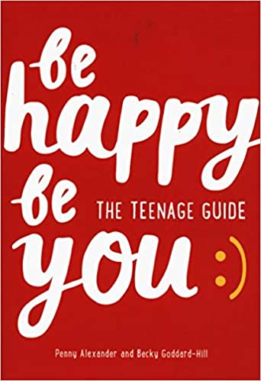

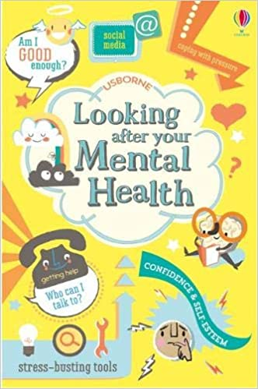

Here are some suggestions of inspirational books, websites & podcasts you may like to have a look at and listen too.

**Online resources**

BBC Radio 1- My mind & Me these short podcasts talks about mental health, stress busting tips from radio 1 and 1Xtra DJ’s, Dr Rahha’s tips on managing stress & pressure, 7 stars reveal how song writing & music helped their mental health.

<https://www.bbc.co.uk/programmes/p04pxgfk>

BBC iplayer – Football, Prince William and Our Mental Health

In this documentary Prince William talks to football stars such as Joe Hart (ex England goal keeper) & Frank Lampard (Chelsea Manager) to explore why men find it so hard to talk about emotions. Prince William wants to use Football as a way to get men/boys talking more to break the taboo that surrounds Mental Health.

<https://www.bbc.co.uk/programmes/m000jkbr>

Here is also a link to YoungMind’s page on looking after yourself during coronavirus.

<https://youngminds.org.uk/find-help/looking-after-yourself/coronavirus-and-mental-health/>

**Books**

**Looking After Your Mental Health**

With lots of practical advice, this lively, accessible guide explains why we have emotions, and what can influence them. Covering everything from friendships, social media and bullying to divorce, depression and eating disorders, this is an essential book for young people.

<https://www.amazon.co.uk/Looking-After-Your-Mental-Health/dp/1474937292/ref=sr_1_1?crid=1XOH2GVJA4VZ1&dchild=1&keywords=looking+after+your+mental+health&qid=1594128669&s=books&sprefix=looking+after+y%2Caps%2C186&sr=1-1>

**Be Happy, Be You**

This positive and insightful guide gives you the tools to build your confidence, eliminate negative feelings and boost happiness in all areas of your life.

<https://www.amazon.co.uk/s?k=be+happy+be+you&i=stripbooks&crid=2T7XB2F36EC14&sprefix=Be+happy%2Cstripbooks%2C181&ref=nb_sb_ss_i_1_8>

**Summer Reading List**

**MHST IS OPEN DURING THE SUMMER HOLIDAYS**

**Please do remember that the MHST is operational 52 weeks of the year, therefore our service continues to be open during the summer holidays and we continue to welcome referrals from parents/carers, young people and schools/colleges.**

**Our working hours are Monday – Friday 09:00-17:00**

**If you would like a referral form please email** [**SouthamptonMHST@solent.nhs.uk**](mailto:SouthamptonMHST@solent.nhs.uk)

**We can send the referral form by email or by post.**

**Alternatively please call on 0300 1236689**

**We wish you all a happy and safe summer holidays.**

**Contact us**

If you have any questions or queries for the

Southampton MHST Team please email us at;

[**SouthamptonMHST@Solent.nhs.uk**](mailto:SouthamptonMHST@Solent.nhs.uk)

Or call us on;

**0300 1236689**

**Happy: Finding joy in every day and letting go of perfect**

A suggested book for parents to look after themselves, build in some self-care and find some balance.

<https://www.amazon.co.uk/s?k=happy+fearne+cotton&i=stripbooks&crid=2028A42TV4Q4K&sprefix=Happy%2Cstripbooks%2C184&ref=nb_sb_ss_i_4_5>

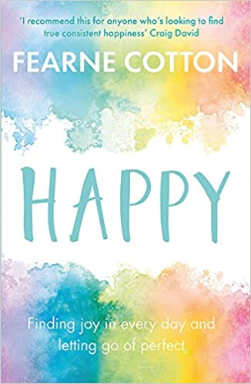

**Summer Reading List continued**

Please see the details of the following services that may also be able to offer you and your child advice and support. Please note that during this unprecedented time services have had to change the way they work and offer support, so please contact the service directly to find out what is currently on offer.

**THE SOLENT WEST CHILD AND ADOLESCENT MENTAL HEALTH SERVICE (CAMHS):**

If your child is currently receiving a service from CAMHS, a duty line for advice in the event of deterioration in your child / young person’s mental health is available. Please request to speak to the duty worker on 0300 123 6661. You are also able to contact the Behaviour Helpline for advice and strategies with managing challenging behaviour on 0300 123 6661, your contact details will be taken and a Behaviour Advisor will return your call within 1 week.

Please be aware that in the current situation there may be a slight delay in responding to duty calls.

**The Public Health Nursing (PHN) Service** offers support to children, young people and their families who live in Southampton.  The team is made up of Nurses, Emotional Health and Wellbeing workers and PHN Assistants; who can offer support for a wide range of health issues such as growth concerns, support with long term conditions, sleep problems, continence issues, general anxiety and much more.  They have a confidential text messaging service called Solent Pulse where you can text any health questions and have them answered by a nurse.  They are currently offering support through telephone calls, emails, text messages and video calling to comply with social distancing rules.  If you would like to contact PHN for support please use one of the methods below:

Phone: 0300 123 6661 Solent Pulse: 07491 163278

Website: <https://what0-18.nhs.uk/solent/school-nursing>

Email: [snhs.publichealthnursingsouthampton@nhs.net](mailto:snhs.publichealthnursingsouthampton@nhs.net)

**USEFUL TELEPHONE NUMBERS:**

**Southampton Multi-Agency Support Hub**: 02380 833336

(Safeguarding advice & parenting support).

**Samaritans:** Free phone 116 123

**Parentline (24 hour advice):** 0808 800 2222

**Child line:**  0800 1111

**NHS direct**: 111 – non emergency helpline

**SANE mental health help line** **(every day 16.30-22.30)** 0300 304 7000

**Young Minds help line (Mon-Fri 9.30-4pm)** 0808 802 5544

**USEFUL WEBSITES – UNDERSTANDING SYMPTOMS, ADVICE AND SELF-HELP:**

* [**https://childdevelopmentinfo.com/**](https://childdevelopmentinfo.com/) **-** This covers numerous ‘symptoms’ of developmental disorders and mental health conditions. It also has a lot of helpful advice ranging from ‘online safety’ to ‘getting children to eat greens’. Mixture of articles and short videos.
* [**www.youngminds.org.uk**](http://www.youngminds.org.uk) **–** information and advice for young people, parents and professionals, includes a telephone advice line and videos. This website covers emotional health, mental health conditions and neurodevelopmental disorders e.g. Attention Deficit Hyperactivity Disorder.
* [**http://www.sane.org.uk/resources/mental_health_conditions/**](http://www.sane.org.uk/resources/mental_health_conditions/) **-** information and advice, includes resources and useful leaflets to manage symptoms of many mental health symptoms. It also has online forums and a telephone advice line (above).
* [**www.getselfhelp.co.uk**](http://www.getselfhelp.co.uk) – this website is an invaluable resource containing free downloadable activities and videos for you to support your child to manage their emotional and mental health.
* [**http://www.moodjuice.scot.nhs.uk/**](http://www.moodjuice.scot.nhs.uk/) **-** Similar to ‘getselfhelp’.
* **Selected mobile phone ‘apps’** to help manage symptoms can be viewed here, although please consider age appropriateness: [**http://www.nhs.uk/Conditions/stress-anxiety-depression/Pages/mental-health-apps.aspx**](http://www.nhs.uk/Conditions/stress-anxiety-depression/Pages/mental-health-apps.aspx) (Or type ‘Apps for Mental Health – NHS Choices into an internet search engine.)

**Useful Services and Websites for Parents and Young People**

**NO LIMITS ADVICE PROJECT** – <https://nolimitshelp.org.uk/> Contact Phone: 02380 224 224 – 13 The High Street, Southampton, SO17 1XN Email: [enquiries@nolimitshelp.org.uk](mailto:enquiries@nolimitshelp.org.uk) **Please contact the service via telephone, email or ‘drop-in’ to the advice centre.**

The No Limits service offer advice and support to young people under the age of 26 years on many issues, including: housing, employment, money management advice, social support, symptoms of mental health, counselling for emotional ill-health, sexual health guidance, drug and alcohol support, victims and perpetrators of crime, plus much more.

**SOUTHAMPTON CITY COUNCIL PARENTING ADVICE AND SUPPORT:**

[**http://sid.southampton.gov.uk/kb5/southampton/directory/results.action?familychannel=8-7-1**](http://sid.southampton.gov.uk/kb5/southampton/directory/results.action?familychannel=8-7-1) **–** Please access this website to view a range of parenting support courses in Southampton. Or go into Southampton City Council’s website and type ‘families’ into the search bar.

Please also contact the Southampton City Council MASH Team on the telephone number above for further advice around services and parenting support.

**RE:MINDS:**

A parent-led support group for families of children with autism or mental health issues.

<https://www.reminds.org.uk/> With a closed Facebook group of over 600 members -https://www.facebook.com/groups/reminds

**CHILDREN WITH SPECIAL NEEDS:**

The Buzz Network - a group for Southampton parents/carers of children with disabilities/special needs. It is open to children with any disability from ADHD to visual impairments, as long as they meet the eligibility criteria. <http://sid.southampton.gov.uk> – type ‘Buzz Network’ into the search engine for contact details.

**CHILDREN WITH SUSPECTED AUTISTIC SPECTRUM DISORDERS** <https://www.autismhampshire.org.uk/> - Autism Hampshire: Information, Advice, ‘Needs Assessment’ and support**.** Community Access, Southampton Office –1648 Parkway, Whiteley, PO15 7AH, Tel: 02380 766162 Email: [**communityaccess@autismhampshire.org.uk**](mailto:communityaccess@autismhampshire.org.uk)

**BEREAVEMENT SUPPORT SERVICES:**

* [**http://www.theredlipstickfoundation.org/**](http://www.theredlipstickfoundation.org/) **-** The Red Lipstick Foundation are here to offer services to families in Hampshire who have been bereaved by suicide or immediate family members following a person’s sudden death.
* [**http://www.simonsays.org.uk/**](http://www.simonsays.org.uk/) **-** Tel: 08453 055 744 -Bereavement service for Children.
* [**http://www.cruse.org.uk/?gclid=CMmGptiMktMCFYWRGwoduC0Ejw**](http://www.cruse.org.uk/?gclid=CMmGptiMktMCFYWRGwoduC0Ejw) **-** National Bereavement Service.

**DOMESTIC ABUSE SUPPORT SERVICES:**

* [**https://www.hamptontrust.org.uk/our-programmes/**](https://www.hamptontrust.org.uk/our-programmes/) **-** support projects for those who have perpetrated domestic abuse, and, adults and young people who have experienced domestic abuse.
* [**https://www.yellowdoor.org.uk/**](https://www.yellowdoor.org.uk/)- Telephone: 023 8063 6313 - support project for adults and young people who have experienced physical and or sexual abuse.

**Useful Services continued**