Complaints Policy

Person responsible - | Helen Jones (Deputy Headteacher)
Last review date - | March 2019
Next review date - | March 2020 (to be ratified in 20/21 due to Covid 19)
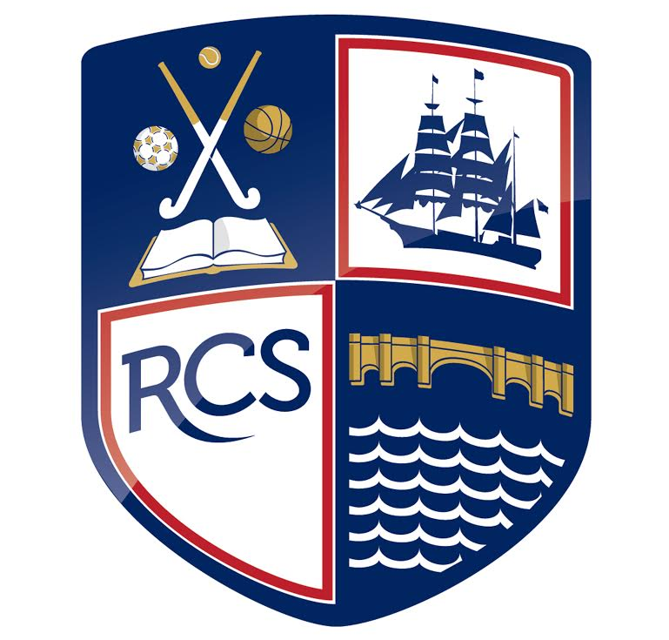
Part 1: Safeguarding Policy
- Who can make a complaint | Page 3
- The difference between a concern and a complaint | Page 3
- How to raise a concern or make a complaint | Page 3
- Anonymous complaints | Page 4
- Time scales | Page 4
- Complaints received outside of term time | Page 4
- Scope of this complaints procedure | Page 4
- Resolving complaints | Page 5
- Withdrawal of a complaint | Page 6
- Stage 1 | Page 6
- Stage 2 | Page 7
- Next steps | Page 8

Contents

Who can make a complaint?

This complaints procedure is not limited to parents or carers of children that are registered at the school. Any person, including members of the public, may make a complaint to Redbridge about any provision of facilities or services that we provide. Unless complaints are dealt with under separate statutory procedures (such as appeals relating to exclusions or admissions), we will use this complaints procedure.

The difference between a concern and a complaint

A concern may be defined as ‘an expression of worry or doubt over an issue considered to be important for which reassurances are sought’.

A complaint may be defined as ‘an expression of dissatisfaction however made, about actions taken or a lack of action’.

It is in everyone’s interest that concerns and complaints are resolved at the earliest possible stage. Many issues can be resolved informally, without the need to use the formal stages of the complaints procedure. Redbridge takes concerns seriously and will make every effort to resolve the matter as quickly as possible.

If you have difficulty discussing a concern with a particular member of staff, we will respect your views. In these cases, a member of the Senior Management team, will refer you to another staff member. Similarly, if the member of staff directly involved feels unable to deal with a concern, a member of the Senior Management team will refer you to another staff member. The member of staff may be more senior but does not have to be. The ability to consider the concern objectively and impartially is more important.

We understand however, that there are occasions when people would like to raise their concerns formally. In this case, Redbridge will attempt to resolve the issue internally, through the stages outlined within this complaints procedure.

How to raise a concern or make a complaint

A concern can be made in person, in writing or by telephone. It may also be made by a third party acting on behalf of a complainant, as long as they have appropriate consent to do so.

Concerns should be raised in the first instance with either the class teacher or tutor who is directly involved in the concern. If the issue remains unresolved, the next step is to make a formal complaint.

Complainants should not approach individual governors to raise concerns or complaints. They have no power to act on an individual basis and it may also prevent them from considering complaints at Stage 2 of the procedure.

Complaints against school staff (except the headteacher) should be made in the first instance, to Mr Jason Ashley (the headteacher) via the school office. Please mark them as Private and Confidential.
Complaints must be written letters and not sent in by email.
Complaints that involve or are about the headteacher should be addressed to Mr David Whalley (the Chair of Governors), via the school office. Please mark them as Private and Confidential.

Complaints about the Chair of Governors, any individual governor or the whole governing body should be addressed to Ms Kate Crisell (the Clerk to the Governing Body) via the school office. Please mark them as Private and Confidential.

In accordance with equality law, we will consider making reasonable adjustments if required, to enable complainants to access and complete this complaints procedure. For instance, providing information in alternative formats, assisting complainants in raising a formal complaint or holding meetings in accessible locations.

Anonymous complaints

We will not normally investigate anonymous complaints. However, the headteacher or Chair of Governors, if appropriate, will determine whether the complaint warrants an investigation.

Time scales

You must raise the complaint within one month of the incident or, where a series of associated incidents have occurred, within one month of the last of these incidents. We will consider complaints made outside of this time frame only if exceptional circumstances apply.

Complaints received outside of term time

We will consider complaints made outside of term time to have been received on the first school day after the holiday period.

Scope of this Complaints Procedure

This procedure covers all complaints about any provision of community facilities or services by Redbridge, other than complaints that are dealt with under other statutory procedures, including those listed below.

Exceptions | Who to contact
- Admissions to schools  - Statutory assessments of Special Educational Needs  - School re-organisation proposals | Concerns about admissions, statutory assessments of Special Educational Needs, or school re-organisation proposals should be raised with Southampton City Council.
- Matters likely to require a Child Protection Investigation | Complaints about child protection matters are handled under our child protection and safeguarding policy and in accordance with relevant statutory guidance.
- Exclusion of children from school* | Further information about raising concerns about exclusion can be found at: www.gov.uk/school-discipline-exclusions/exclusions.  *complaints about the application of the behaviour policy can be made through the school’s complaints procedure at: www.redbridgecommunityschool.com/policies. Select the policy titled ‘Attendance, Behaviour, Student Access & Anti-Bullying”.
- Whistleblowing | We have an internal whistleblowing procedure for all our employees, including temporary staff and contractors.  The Secretary of State for Education is the prescribed person for matters relating to education for whistleblowers in education who do not want to raise matters direct with their employer. Referrals can be made at: www.education.gov.uk/contactus.  Volunteer staff who have concerns about our school should complain through the school’s complaints procedure.
- Staff grievances | Complaints from staff will be dealt with under the school’s internal grievance procedures.
- Staff conduct | Complaints about staff will be dealt with under the school’s internal disciplinary procedures, if appropriate.  Complainants will not be informed of any disciplinary action taken against a staff member as a result of a complaint. However, the complainant will be notified that the matter is being addressed.
- Complaints about services provided by other providers who may use school premises or facilities | Providers should have their own complaints procedure to deal with complaints about service. Please contact them direct.
- National Curriculum - content | Please contact the Department for Education at:  www.education.gov.uk/contactus

If other bodies are investigating aspects of the complaint, for example the police, local authority (LA) safeguarding teams or Tribunals, this may impact on our ability to adhere to the timescales within this procedure or result in the procedure being suspended until those public bodies have completed their investigations.

If a complainant commences legal action against Redbridge in relation to their complaint, we will consider whether to suspend the complaints procedure in relation to their complaint until those legal proceedings have concluded.

Resolving complaints

At each stage in the procedure, Redbridge wants to resolve the complaint. If appropriate, we will acknowledge that the complaint is upheld in whole or in part. In addition, we may offer one or more of the following:

- an explanation

- an admission that the situation could have been handled differently or better

- an assurance that we will try to ensure the event complained of will not recur

- an explanation of the steps that have been or will be taken to help ensure that it will not happen again and an indication of the timescales within which any changes will be made

- an undertaking to review school policies in light of the complaint

- an apology.

Withdrawal of a Complaint

If a complainant wants to withdraw their complaint, we will ask them to confirm this in writing.

Stage 1

Formal complaints must be made to the headteacher (unless they are about the headteacher), via the school office. This may only be done, in writing.

The headteacher will decide who within the Senior Management team will deal with the complaint. They will then record the date the complaint is received and will acknowledge receipt of the complaint in writing within 2 school days.

Note: The headteacher may delegate the investigation to a member of the school’s Senior Management team but not the decision to be taken.

During the investigation, the headteacher (or investigator) will:
- if necessary, interview those involved in the matter and/or those complained of, allowing them to be accompanied if they wish
- keep a written record of any meetings/interviews in relation to their investigation.

At the conclusion of their investigation, the member of the Senior Management team will provide a formal written response within 5 school days of the date of receipt of the complaint.

If the member of the Senior Management team is unable to meet this deadline, they will provide the complainant with an update and revised response date.

The response will detail any actions taken to investigate the complaint and provide a full explanation of the decision the headteacher has made and the reason(s) for it. Where appropriate, it will include details of actions Redbridge will take to resolve the complaint.

The member of the Senior Management Team will advise the complainant of how to escalate their complaint should they remain dissatisfied with the outcome of Stage 1.

If the complaint is about the headteacher, or a member of the governing body (including the Chair or Vice-Chair), a suitably skilled governor will be appointed to complete all the actions at Stage 1.

Complaints about the Chair of Governors or member of the governing body must be made to the Clerk, via the school office.

If the complaint is:

- jointly about the Chair and Vice Chair or

- the entire governing body or

- the majority of the governing body

Stage 1 will be considered by an independent investigator appointed by the governing body. At the conclusion of their investigation, the independent investigator will provide a formal written response.

Stage 2

If the complainant is dissatisfied with the outcome at Stage 1 and wishes to take the matter further, they can escalate the complaint to Stage 2 – a letter to the Chair of Governors. This is the final stage of the complaints procedure.

A request to escalate to Stage 2 must be made in writing to the Chair of Governors, via the school office, within 5 school days of receipt of the Stage 1 response.

The Chair of Governors will record the date the complaint is received and acknowledge receipt of the complaint in writing within 2 school days.

Requests received outside of this time frame will only be considered if exceptional circumstances apply.

The Chair of Governors will then conduct an investigation regarding the complaint and will reply, in writing, within 5 working days.

The Chair of Governors will consider the complaint and the investigation that has occurred. The Chair of Governors can:

- uphold the complaint in whole or in part

- dismiss the complaint in whole or in part.

If the complaint is upheld in whole or in part, the Chair of Governors will:

- decide on the appropriate action to be taken to resolve the complaint

- where appropriate, recommend changes to the school’s systems or procedures to prevent similar issues in the future.

The letter to the complainant will include details of how to contact the Department for Education if they are dissatisfied with the way their complaint has been handled by Redbridge.

If the complaint is:

- jointly about the Chair and Vice Chair or

- the entire governing body or

- the majority of the governing body

Stage 2 will be heard by a committee of independent, co-opted governors.

The response will detail any actions taken to investigate the complaint and provide a full explanation of the decision made and the reason(s) for it. Where appropriate, it will include details of actions Redbridge will take to resolve the complaint.

The response will also advise the complainant of how to escalate their complaint should they remain dissatisfied.

Next Steps

If the complainant believes the school did not handle their complaint in accordance with the published complaints procedure or they acted unlawfully or unreasonably in the exercise of their duties under education law, they can contact the Department for Education after they have completed Stage 2.

The Department for Education will not normally reinvestigate the substance of complaints or overturn any decisions made by Redbridge. They will consider whether Redbridge has adhered to education legislation and any statutory policies connected with the complaint.

The complainant can refer their complaint to the Department for Education online at: www.education.gov.uk/contactus, by telephone on: 0370 000 2288 or by writing to:

Department for Education
Piccadilly Gate
Store Street
Manchester
M1 2WD.

