Shine and More Able Policy

Person responsible - | Jon Colebrook
Last review date - | November 2020. (Updated July 2018, Oct 2019, Nov 2020)
Review date - | November 2022
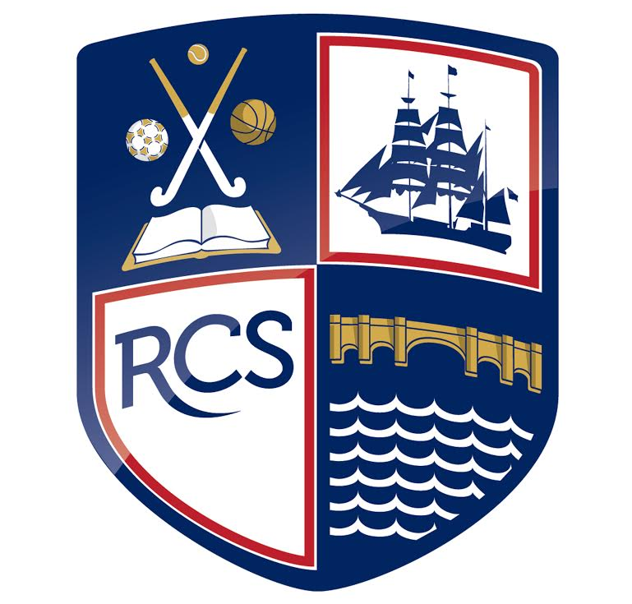
Contents |  |  | Page
 | Vision | 3
 | Objectives | 3
 | Definition of Most Able | 3
 | Identification of Most Able Students | 4
 | Provision | 4

Shine and More Able Policy

At Redbridge Community School we believe that all students are entitled to an education that will enable them to achieve their full potential and support them in reaching their aspirations. All students have individual needs and we believe that our role as a school is to meet those needs and provide a personalised learning experience for each and every student. Redbridge students who are amongst the most able in the school and require a high level of stretch and challenge are referred to as our Shine students.

Vision

Our vision is to offer the best provision for our Shine students within every subject area. We aim to create a stimulating and challenging learning environment to ensure that our Shine students are given opportunities to fulfil their potential and maximise their progress. We aim to provide this by offering activities that enrich and extend their learning both inside and outside of the classroom, which will result in higher attainment as is consistent with the national picture.

Objectives

- To ensure that Shine students receive support and guidance in achieving their academic and personal goals
- To provide Shine students with opportunities to develop as individuals and generate their own learning
- To encourage independence and creativity in Shine students both inside and outside the classroom
- To develop a consistent approach across the curriculum in order that all staff members can best support Shine students

Definition of Shine

Key stage 2 data is our starting point for identifying and defining shine students. We define Shine students as those who have achieved significantly above the national average of 100 in the KS2 grading system. This definition is in line with the guidance given to secondary schools by OFSTED. These students will be tracked and monitored as an identified Shine cohort through Years 7 to 11 with the aim of ensuring that these students make exceptional progress by the end of Year 11, achieving 7-9 in their GCSE subjects. The key stage 2 data is only the first consideration made when identifying our shine cohort.

Identification of Shine Students

Our identification process is ongoing and the responsibility of all staff at the school. In the first instance we will use our internal data from our Knowledge and Skills tests, and the Key Stage 2 data provided by the primary school cluster as well as previous class teachers' knowledge of the students. Furthermore students who have English as an additional language (EAL), no KS2 data and/or have joined the school after the start of Year 7 will be assessed by the Shine and More Able Co-ordinators in order to ensure our Shine subgroup is comprehensive and as accurate as possible. Year 7’s are added to our Shine cohort in December once we have had a chance to know the cohort better. This is because we have found in the past Key stage 2 data to be unreliable on some occasions.

In addition to the whole school data-based Shine subgroup, teachers can also nominate students to be added to the More Able subgroup. A student can be added to the More Able subgroup in a particular subject if they show exceptional ability in that subject and they meet the criteria set by the department. Staff nominations take place twice a year, usually in December and June, and students with three or more nominations from different subject areas will be considered for the Shine subgroup, with the final decision being made by the Shine and More Able Co-ordinators. The provision detailed below will also be available to our More Able students.

Provision

There will be three main strands of provision for our Shine students: whole school, in the classroom and outside the classroom. There will be regular reviews and evaluations of the effectiveness of these approaches to ensure we are best meeting the needs of our students.

Provision on a whole school level:

We have a Shine and More Able Co-ordinator, who is responsible for overseeing the progress of the Shine students throughout their time at Redbridge. The Co-ordinator will liaise with the Senior Management Team and Progress Leaders during the identification process and will have regular meetings to monitor the Shine students’ progress.
The attendance, punctuality and behaviour of our Shine students will be closely monitored also which will provide us with an overall profile of each student. Early identification of a Shine student who is not making the most of their time in school will allow us to intervene with the intention of improving these aspects of the student’s school life and therefore raise their attainment. In addition, there will be Shine tutor groups in Years 10 and 11 who will follow a bespoke tutor programme aimed at stretching and challenging the Shine students.
In order to raise the profile of our Shine students we will celebrate their achievements in assemblies and at special events throughout the year. Furthermore there will be regular updates of the Shine students’ successes on the school website and in the Bridge school magazine.
Each department is responsible for keeping an up-to-date Shine and More Able policy which outlines how Shine students are supported within that subject area. These will be regularly evaluated and improved to ensure that each subject is endeavouring to best meet the needs of our Shine students.

Provision in the classroom:

At Redbridge we pride ourselves on providing consistent quality first teaching across the school, which is monitored through teacher observations, SMT learning walks, and line management. In addition to this we aim to provide a stimulating curriculum that stretches our Shine students which is frequently reviewed to verify that we are doing just that.
During the training process of new staff and trainee teachers, they are given advice about how to best meet the needs of Shine students. This training is regularly reviewed and evaluated to guarantee that all staff joining Redbridge know how to support and challenge Shine students in their classrooms.
The Redbridge Lead Practitioners are teachers who have proven to be among the most talented teachers at the school. As part of their role they mentor other staff members in teaching and learning strategies, among which are approaches that are considered to be best practice for Shine students. Our RLPs are a valuable resource for all staff members to draw on and are available to answer any queries that teaching staff may have.
All teaching staff are responsible for monitoring the progress of their pupils and offering intervention to any student they believe may need additional support in achieving their potential. This may take the form of in-class assistance or after school sessions, depending on the needs of the individual student. In every lesson there is at least one opportunity for all students to be stretched and challenged through the ‘A Chance to Shine’ initiative, which involves more complex tasks being available to further the students’ learning.

Provision outside the classroom:

We believe that learning does not only take place in the classroom, therefore it is important that we offer our students opportunities to further develop and extend their learning beyond the classroom.
Engaging with the parents and carers of our Shine students is of high importance to us. Parents and carers will be contacted when their child is added to the Shine Subgroup and will be provided with information about any of the programmes their child is involved with. Advice on how to support Shine students at home will also be made available and parents and carers will be able to contact the Shine and More Able Co-ordinators with any queries or concerns they may have.
Redbridge will work with outside agencies including local colleges and universities to offer Shine students access to external programmes that will enhance their learning. The Shine and More Able Co-ordinators will carefully consider which schemes would be most suitable and beneficial for the students before taking part.

Policy updated: November 2020
Shine and More Able Co-ordinator: Mrs R. Lang
SMT Link for Shine and More Able: Mr J. Colebrook

