Relationships and Sexual Education (RSE) Policy

Person responsible - | Alex Hoyle (Assistant Headteacher)
Last review date - | October 2020
Next review date - | ?
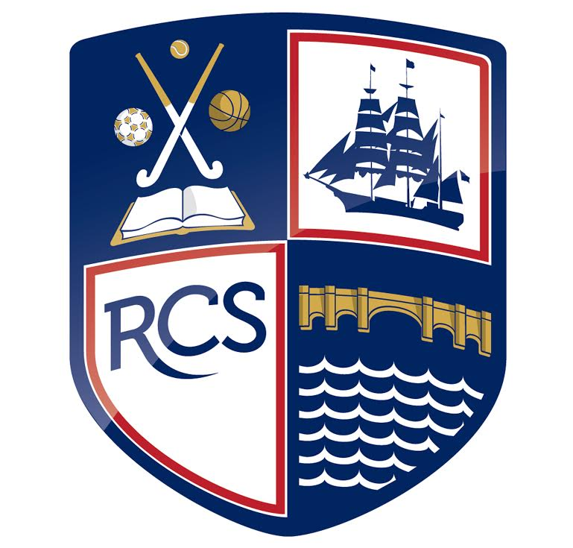
Part 1: Safeguarding Policy
- Defining RSE | Page 3
- Aims and Values | Page 3
- Attitude and Values | Page 3
- Personal and Social Skills | Page 3
- Knowledge and Understanding | Page 3
- Delivery of RSE | Page 4
- Content of the School RSE Programme | Page 4
- Methods of Teaching and Resourcing | Page 4
- Assessment of RSE | Page 5
- Dealing with Sensitive Issues | Page 5
- Monitoring and Evaluating RSE | Page 5
- Visitors Contribution to RSE | Page 5

Contents

Defining RSE

“Effective RSE does not encourage early sexual experimentation. It should teach young people to understand human sexuality and to respect themselves and others. It enables young people to mature, build their confidence and self-esteem and understand reasons for delaying sexual activity. Effective RSE also supports people throughout life to develop safe, fulfilling and healthy sexual relationships at the appropriate time.” DfE Statutory Guidance for Relationships and Sex Education (RSE)

Redbridge Community School believes that Relationships and Sex Education (RSE) is fundamental to help pupils lead happy, healthy lives. The aims of our RSE programme are:
- To enable our students better to understand the nature of human relationships.
- To enable students to see the importance of stable, loving relationships for the bringing up of children.
- To prepare students for the changes which occur to their bodies, minds and emotions as a consequence of growth from childhood to adulthood.
- To equip students with the knowledge and emotional maturity to have happy and healthy relationships when they leave school.

At Redbridge Community School, RSE provision is inclusive of all pupils and consistent with the equalities duties of the school. If parents are not happy with the RSE that the school provides, they have a right to express those concerns to the school.

Aims and values
At Redbridge Community School, RSE has three main elements, all of which are important for a balanced RSE programme:

Attitudes and values
- learning the importance of values, individual conscience and moral considerations; learning the value of family life and stable and loving relationships for the nurture of children
- learning the value of respect, love and care
- exploring, considering and understanding moral dilemmas
- developing critical thinking as part of decision-making.

Personal and social skills
- learning to manage emotions and relationships confidently and sensitively
- developing self-respect and empathy for others
- learning to make choices based on an understanding of difference and with an absence of prejudice
- developing an appreciation of the consequences of choices made
- managing conflict
- learning how to recognise and avoid exploitation and abuse.

Knowledge and understanding
- learning and understanding physical development at appropriate stages
- understanding human sexuality, reproduction, sexual health, emotions and relationships
- learning about contraception and the range of local and national sexual health advice, contraception and support services
- learning the reasons for delaying sexual activity, and the benefits to be gained from such delay
- the avoidance of unplanned pregnancy.

Delivery of RSE
RSE is delivered within PSHE, Science lessons, assemblies and tutor time sessions. Most sessions are led by pastoral teams (tutors, head of years) but where possible we also invite experts into school to facilitate sessions in the form of workshops and assemblies. The STAR project facilitate ‘Girl Talk’ and ‘Lad chat’ with Year 10 pupils and also assemblies with a focus on relationships with each Year group. No limits facilitate ‘let’s talk RSE’ workshops with Year 9 pupils. Our Healthy Living Advisor ELSA, school counsellor and well-being co-ordinator also offer bespoke sessions to all year groups. All teaching staff within the school have the responsibility of delivering RSE to pupils in a safe and informative manner. They are responsible for modelling good relationships within school. Much of the general work in school is based on good relationships and in this regard, RSE is supported by the school’s key aspirations. It is the responsibility of the Science department’s staff to deliver aspects of the Science National Curriculum Science, according to their Schemes of Work.

Content of the school’s RSE programme

Sexual Health:
YEAR 7 - Puberty
YEAR 8 - Sexuality and Gender identity
YEAR 9 - Laws (sex/consent) contraceptives and pregnancy
YEAR 10 - Reproductive health and sexually transmitted diseases

Relationships:
YEAR 7 - Positive friendships and Teen relationships
YEAR 8 - Family roles/positive role models and Abusive relationships
YEAR 9 - Peer-pressure and Exploitation
YEAR 10 – Conflict/resolution and Revenge porn

Methods of teaching and resourcing
In the delivery of RSE, teachers will use a variety of teaching methods and resources. The following are recognised methods for the effective delivery of RSE:
- Discussion
- Videos
- Drama and role play
- Presentations

Teachers will also use other teaching methods to enable students to learn about RSE which are age appropriate, taking into account the developmental needs of individual students. Parents are welcome to discuss with teachers their approach to RSE and the methods of teaching and learning to be used. The school uses a wide variety of resources, including videos, power point presentations and leaflets. Parents are welcome to view these materials.

Assessment of RSE
RSE delivered according to the National Curriculum Science will be assessed within Science lessons with knowledge and skills tests. These will be marked by Science teachers.
RSE delivered within PSHE lessons will be assessed using an end-of-unit skills and knowledge test.

Dealing with sensitive issues
Teachers need to be sure that they are aware of issues that may arise out of teaching and learning about RSE. The following are protocols for discussion based lessons with students:
- no one (teacher or student) will have to answer a personal question
- no one will be forced to take part in a discussion
- only the correct names for body parts will be used
- meanings of words will be explained in a sensible and factual way
- teachers may use their discretion in responding to questions and may say that the appropriate person to answer that question is the parent.

Where a member of staff is concerned that a child protection issue is arising, it is his/her responsibility to follow the school’s policy in this matter.

Monitoring and evaluating RSE
RSE is monitored within the school by Alexander Hoyle (Assistant Deputy Head Teacher) and Coralie Crisell (PSHE Coordinator), who both monitor the number of hours of RSE that pupils are provided with and carefully evaluate the content which is delivered to pupils, considering the needs of pupils within Redbridge Community School. When monitoring RSE, they:
- ensure that RSE occurs in the school’s curriculum
- monitor the use of teaching and learning styles
- monitor the use of teaching materials
- evaluate the effectiveness of the school’s programme.

Visitors contributing to RSE
Redbridge Community School works with charities and visitors from outside of the school to deliver RSE to pupils. The school will invite local experts on issues relating to RSE as well as use health and other professionals associated with the school to deliver RSE. All school associate health and other professional visitors will be asked to conform to the following:
- visitors contributing to RSE will do so at the invitation of the school and will be qualified to make an appropriate contribution
- visitors must agree with the aims of the school in delivering its policy on RSE
- when in class, visitors will be supervised by a member of staff, who will be present at all times
- visitor will follow the school’s child protection procedures if a disclosure occurs within the classroom setting
- visitors will know and understand where their contribution fits into the school’s programme for RSE and PSHE.

