**Southampton Mental Health Support Team**

**Secondary Schools/Colleges Wellbeing Newsletter**

**This week’s theme - Online Safety & Mental Health 6th May 2020**

With Schools and colleges closed we appreciate that for you as young people and adolescents, life has moved almost entirely online.  This means that talking about using the internet safely and protecting our mental health online are more important than ever.

It can be boring and really lonely being at home all day and not seeing our friends and other people who are important to us, especially if parents are working.  It is normal to try and look for other ways to fill our time or socialise and things like Tic Tok or Instagram challenges can be really fun, creative and rewarding.  But it is really important to think about how to do this safely.  This means being open with parents and carers about online activities and also learning some good skills to keep ourselves safe.  This website: [www.thinkuknow.co.uk](http://www.thinkuknow.co.uk) has some info for you if you’re 11-13 or 14+ to help you understand stuff like your digital footprint (that everything you post online leaves a footprint) and advice about live streaming and how to handle people who ask you to do things you’re not comfortable with. [www.bullying.co.uk](http://www.bullying.co.uk)  has loads of great advice about dealing with people who might be making you feel bad about yourself online.

During the current pandemic there has been a lot of news circulating and with

spending a lot more of our time online, we have been flooded with news (both

real and fake). While it is important to have an awareness of the world around

us, having an altered perspective due to fake news or overly checking the news

can have a negative impact on our mental health.

We can support our mental health by limiting the amount of news read/watched, not reading or watching the news just before going to bed and ensuring news is real.

Here are some tips for checking if news is real or fake:

* Consider the source - some websites claim that they are a fantasy or alternative news site, if this is the case then it is 99% likely that what they are publishing is fiction. News sources such as BBC News (<https://www.bbc.co.uk/news> ) publish up to date news which is fact checked prior to publication.
* What is the support – where are the facts and figure in news stories coming from? Did you know that you can look up information on the office for national statistics (<https://www.ons.gov.uk/> ) to find official information rather than someone’s interpretation of it.
* Check the date – prior to the lockdown there was a news story doing the rounds that 10,000 troops from around the world were being deployed in the UK, this story, while correct referred to a training exercise which happened in March 2019. Sharing this news story a year later led to panic and unnecessary worry.
* Ask someone – If you still aren’t sure is a news story is real, fake or satire; ask someone what they think. Alternatively websites such as Full Facts (<https://fullfact.org/> ) find, expose and counter fake news and provide the real facts from reputable sources.



**News – real or fake?**

**Parents Top Tips**

Whilst there are many benefits to being online, parents can sometimes feel concerned about activities or content that their young people are accessing. Your young person can experience harm online, including child sexual abuse, exposure to radicalising content, youth-produced sexual imagery (‘sexting’), cyberbullying, exposure to age-inappropriate content, such as pornography and exposure to harmful content, such as suicide content. More information can be found at <https://www.gov.uk/government/publications/coronavirus-covid-19-keeping-children-safe-online/coronavirus-covid-19-support-for-parents-and-carers-to-keep-children-safe-online>

As a parent, there are ways you can remain vigilant and keep your young person safe from harm.

* Educate yourself about social media, familiarising yourself with available apps and which ones are appropriate for your child.
* Establish an age limit for your young person to start using social media. Most social media sites require users to be 13 years old to be able to create an account without their parents’ permission.
* Remain vigilant and regularly check privacy settings. Settings often need to be manually updated by the user.
* Ensure your young person keeps their profile private so that only people who they have friended are able to see the content on their profile.
* Make sure they don’t share personal details about themselves, such as their address, email address, phone numbers or check-ins. Ensure your young person understands why this shouldn’t be shared.
* Remind them never to share photos or videos which jeopardize their safety or character. Ensure they only post things which share themselves, and others, in a positive light as it is easy for things to be taken out of context online and the wrong message may be portrayed.
* Talk to your young person about the importance of considering others when engaging online. Remind them to seek permission first if they are thinking about sharing a video or photo and to consider other people’s feelings before they share something. Discuss with them the consequences of misusing social media.
* Ensure they choose a strong password and never share this password with anyone.
* Educate your young person not to accept friend requests from people they don’t know, and highlight they should only accept friends and family. Ask them to inform you whenever they receive messages or invites from strangers.
* Set parental rules or guidelines for your young person’s social media use. Try to set rules which empower him/her to make good decisions on their own.
* You cannot monitor your young person’s social media activity 24/7, so it is key to maintain a strong line of open communication with them about online safety. Reinforce the message to talk to you or another trusted adult if anything happens online which makes them feel uncomfortable, worried, scared or sad. Equally, if someone is teasing or harassing them as these could be signs of cyber-bullying. Let them know you will be there to support them.

**Safe and fun things to do with friends online;**

Whatsapp, Houseparty & Zoom are some of the ways that people are socialising with friends and family at this time…even more than ever. We looked at some ideas for some games and activities you can do with your favourite people and stay safe online and these are our top 6:

1. Bake Off or Nailed It - Compare your baking creations with friends.
2. Quiz- Give each friend a category such as films or music and each write 10 questions.
3. Karaoke- try the free Watch2Gether app to ensure you sing together with you friends and family
4. Bingo- get the family together for an online Bingo night. Use the amazing randomwordgenerator.com to come up with random numbers (also has a tool for Pictionary!)
5. Check out the online concerts and theatre productions being streamed for free [www.list.co.uk](http://www.list.co.uk) [www.ntlive.nationaltheatre.org.uk](http://www.ntlive.nationaltheatre.org.uk) youtube.com (The Shows Must Go On) [www.timeout.com](http://www.timeout.com) – use the Watch2Gether App to watch with friends and family
6. The 30 Day Song Challenge- Use this template to find 30 songs and share with friends…you might discover some new favourites!

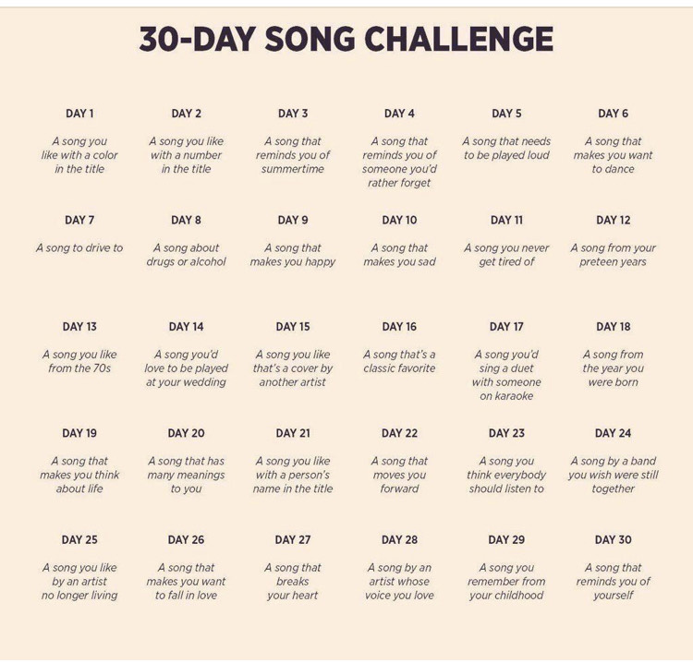

**Activities of the week**

Being able to communicate with each other is such an important human need.

How we communicate and how often can vary from person to person, some

of us like daily verbal conversations, others prefer to use social media apps like

WhatsApp or imessage. Currently during Covid-19 pandemic, families, friends

as well as businesses are connecting through so many different social media

resources.

Many of you will be aware of Joe Wicks the Fitness Instructor (Body Coach) who has brought so many children and adults together online at the same time to take part in his PE sessions. Connecting people in this way is good for our mental health as well as keeping us fit and active. If you have not tried Joe’s daily PE session, encourage your family and friends to have a go. Some of his more recent sessions have included a fun element of Joe dressing up as a Frog and a Knight. You can find Joe’s PE sessions on Youtube. Joe is donating all of his viewing revenue to NHS Charities Together which is an amazing show of support and appreciation.

<https://www.youtube.com/user/thebodycoach1/videos>

There are many other people such as music artists sharing virtual concerts, Poets sharing messages of hope, theatre shows, museums uploading virtual tours and chefs and bakers filming themselves cooking and baking delicious things to eat. Big time YouTubers are donating the profits to the NHS they make from their AdSense revenue.

Here is a link to watch:

<https://www.bbc.co.uk/one-world-together/episode/p089pbzg/one-world-together-at-home-tracks-little-mix-touch>

All of the above is a positive aspect of using online technology and social media apps which demonstrates Unity across the world, bringing people together.



Staying active: This week we tried a 10 minute dance exercise

class called DDMIX Daily Shake up and asked some young people

what they thought…

“It was fun and we had a laugh in the lounge doing the moves.”

“It made me feel energised.”

“I was happy after I did it…it was fun.”

Try it for yourself by asking an adult to log into their Facebook account and go to facebook.com/diversedancemix daily at 1.30 PM

**Good News Story**





**Keeping Active**

**Contact us**

If you have any questions or queries for the

Southampton MHST Team please email us at;

**SouthamptonMHST@Solent.nhs.uk**

Yoga

Please see the details of the following services that may also be able to offer you and your child advice and support. Please note that during this unprecedented time services have had to change the way they work and offer support, so please contact the service directly to find out what is currently on offer.

**THE SOLENT WEST CHILD AND ADOLESCENT MENTAL HEALTH SERVICE (CAMHS):**

If your child is currently receiving a service from CAMHS, a duty line for advice in the event of deterioration in your child / young person’s mental health is available. Please request to speak to the duty worker on 0300 123 6661. You are also able to contact the Behaviour Helpline for advice and strategies with managing challenging behaviour on 0300 123 6661, your contact details will be taken and a Behaviour Advisor will return your call within 1 week.

Please be aware that in the current situation there may be a slight delay in responding to duty calls.

**The Public Health Nursing (PHN) Service** offers support to children, young people and their families who live in Southampton.  The team is made up of Nurses, Emotional Health and Wellbeing workers and PHN Assistants; who can offer support for a wide range of health issues such as growth concerns, support with long term conditions, sleep problems, continence issues, general anxiety and much more.  They have a confidential text messaging service called Solent Pulse where you can text any health questions and have them answered by a nurse.  They are currently offering support through telephone calls, emails, text messages and video calling to comply with social distancing rules.  If you would like to contact PHN for support please use one of the methods below:

Phone: 0300 123 6661 Solent Pulse: 07491 163278

Website: <https://what0-18.nhs.uk/solent/school-nursing>

Email: [snhs.publichealthnursingsouthampton@nhs.net](mailto:snhs.publichealthnursingsouthampton@nhs.net)

**USEFUL TELEPHONE NUMBERS:**

**Southampton Multi-Agency Support Hub**: 02380 833336

(Safeguarding advice & parenting support).

**Samaritans:** Free phone 116 123

**Parentline (24 hour advice):** 0808 800 2222

**Child line:**  0800 1111

**NHS direct**: 111 – non emergency helpline

**SANE mental health help line** **(every day 16.30-22.30)** 0300 304 7000

**Young Minds help line (Mon-Fri 9.30-4pm)** 0808 802 5544

**USEFUL WEBSITES – UNDERSTANDING SYMPTOMS, ADVICE AND SELF-HELP:**

* [**https://childdevelopmentinfo.com/**](https://childdevelopmentinfo.com/) **-** This covers numerous ‘symptoms’ of developmental disorders and mental health conditions. It also has a lot of helpful advice ranging from ‘online safety’ to ‘getting children to eat greens’. Mixture of articles and short videos.
* [**www.youngminds.org.uk**](http://www.youngminds.org.uk) **–** information and advice for young people, parents and professionals, includes a telephone advice line and videos. This website covers emotional health, mental health conditions and neurodevelopmental disorders e.g. Attention Deficit Hyperactivity Disorder.
* [**http://www.sane.org.uk/resources/mental_health_conditions/**](http://www.sane.org.uk/resources/mental_health_conditions/) **-** information and advice, includes resources and useful leaflets to manage symptoms of many mental health symptoms. It also has online forums and a telephone advice line (above).
* [**www.getselfhelp.co.uk**](http://www.getselfhelp.co.uk) – this website is an invaluable resource containing free downloadable activities and videos for you to support your child to manage their emotional and mental health.
* [**http://www.moodjuice.scot.nhs.uk/**](http://www.moodjuice.scot.nhs.uk/) **-** Similar to ‘getselfhelp’.
* **Selected mobile phone ‘apps’** to help manage symptoms can be viewed here, although please consider age appropriateness: [**http://www.nhs.uk/Conditions/stress-anxiety-depression/Pages/mental-health-apps.aspx**](http://www.nhs.uk/Conditions/stress-anxiety-depression/Pages/mental-health-apps.aspx) (Or type ‘Apps for Mental Health – NHS Choices into an internet search engine.)

**Useful Services and Websites for Parents and Young People**

**NO LIMITS ADVICE PROJECT** – <https://nolimitshelp.org.uk/> Contact Phone: 02380 224 224 – 13 The High Street, Southampton, SO17 1XN Email: [enquiries@nolimitshelp.org.uk](mailto:enquiries@nolimitshelp.org.uk) **Please contact the service via telephone, email or ‘drop-in’ to the advice centre.**

The No Limits service offer advice and support to young people under the age of 26 years on many issues, including: housing, employment, money management advice, social support, symptoms of mental health, counselling for emotional ill-health, sexual health guidance, drug and alcohol support, victims and perpetrators of crime, plus much more.

**SOUTHAMPTON CITY COUNCIL PARENTING ADVICE AND SUPPORT:**

[**http://sid.southampton.gov.uk/kb5/southampton/directory/results.action?familychannel=8-7-1**](http://sid.southampton.gov.uk/kb5/southampton/directory/results.action?familychannel=8-7-1) **–** Please access this website to view a range of parenting support courses in Southampton. Or go into Southampton City Council’s website and type ‘families’ into the search bar.

Please also contact the Southampton City Council MASH Team on the telephone number above for further advice around services and parenting support.

**RE:MINDS:**

A parent-led support group for families of children with autism or mental health issues.

<https://www.reminds.org.uk/> With a closed Facebook group of over 600 members -https://www.facebook.com/groups/reminds

**CHILDREN WITH SPECIAL NEEDS:**

The Buzz Network - a group for Southampton parents/carers of children with disabilities/special needs. It is open to children with any disability from ADHD to visual impairments, as long as they meet the eligibility criteria. <http://sid.southampton.gov.uk> – type ‘Buzz Network’ into the search engine for contact details.

**CHILDREN WITH SUSPECTED AUTISTIC SPECTRUM DISORDERS** <https://www.autismhampshire.org.uk/> - Autism Hampshire: Information, Advice, ‘Needs Assessment’ and support**.** Community Access, Southampton Office –1648 Parkway, Whiteley, PO15 7AH, Tel: 02380 766162 Email: [**communityaccess@autismhampshire.org.uk**](mailto:communityaccess@autismhampshire.org.uk)

**BEREAVEMENT SUPPORT SERVICES:**

* [**http://www.theredlipstickfoundation.org/**](http://www.theredlipstickfoundation.org/) **-** The Red Lipstick Foundation are here to offer services to families in Hampshire who have been bereaved by suicide or immediate family members following a person’s sudden death.
* [**http://www.simonsays.org.uk/**](http://www.simonsays.org.uk/) **-** Tel: 08453 055 744 -Bereavement service for Children.
* [**http://www.cruse.org.uk/?gclid=CMmGptiMktMCFYWRGwoduC0Ejw**](http://www.cruse.org.uk/?gclid=CMmGptiMktMCFYWRGwoduC0Ejw) **-** National Bereavement Service.

**DOMESTIC ABUSE SUPPORT SERVICES:**

* [**https://www.hamptontrust.org.uk/our-programmes/**](https://www.hamptontrust.org.uk/our-programmes/) **-** support projects for those who have perpetrated domestic abuse, and, adults and young people who have experienced domestic abuse.
* [**https://www.yellowdoor.org.uk/**](https://www.yellowdoor.org.uk/)- Telephone: 023 8063 6313 - support project for adults and young people who have experienced physical and or sexual abuse.

**Useful Services continued**