Personal, Social, Health and Economic (PSHE) education Policy

Person responsible - | Alex Hoyle (Assistant Headteacher)
Last review date - | ?
Next review date - | ?
Part 1: Safeguarding Policy
- Defining PSHE | Page 3
- Aims and Values | Page 3
- Delivery of PSHE | Page 3
- Content of the School PSHE Programme | Page 4
- Curriculum calendar | Page 4
- Methods of Teaching and Resourcing | Page 5
- Assessment of PSHE | Page 5
- Dealing with Sensitive Issues | Page 5
- Visitors Contribution to PSHE | Page 5

Contents

This policy covers our school’s approach to personal, social, health and economic (PSHE) education.
Currently under the Education Act, 2002/Academies Act 2010 all schools must provide a balanced and broadly-based curriculum which:
- promotes the spiritual, moral, cultural, mental and physical development of pupils at the school and of society, and
- prepares pupils at the school for the opportunities, responsibilities and experiences of later life.
Defining PSHE
‘Personal, Social, Health and Economic (PSHE) education is a school subject through which pupils develop the knowledge, skills and attributes they need to manage their lives, now and in the future.
These skills and attributes help pupils to stay healthy, safe and prepare them for life and work in modern Britain. When taught well, PSHE education helps pupils to achieve their academic potential, and leave school equipped with skills they will need throughout later life.’ PSHE association

Aims and Values
Our PSHE education programme is underpinned by the school values of Aspiration, Respect, Opportunity and Excellence.
- To create an ethos where all learners realise their potential and have a strong desire to exceed their goals.
- To develop a school community where differences are celebrated and all members of the community demonstrate consideration to others.
- To use the resources of the school to acquire and promote outstanding opportunities in and out of the classroom.
- To excel in all of the opportunities available through effort and hard work.
This policy is informed by the school’s safeguarding/child protection policy (which can be viewed on the school website) and we will create a safe and supportive learning environment by ensuring that all pupils adhere to clearly set out ground rules in every PSHE session.
As with all lessons at Redbridge, teaching of PSHE sessions will take into account the age, ability, readiness, and cultural backgrounds of children [and those with English as a second language] to ensure that all can fully access PSHE education provision. We recognise the right for all pupils to have access to PSHE education learning which meets their needs.

Delivery of PSHE
PSHE is delivered within tutor time sessions, Science lessons and assemblies. Most sessions are led by pastoral teams (tutors, head of years) but where possible we also invite experts into school to facilitate sessions in the form of workshops and assemblies. The STAR project facilitate ‘Girl Talk’ and ‘Lad chat’ with Year 10 pupils and also assemblies with a focus on relationships with each Year group. No limits facilitate ‘let’s talk RSE’ workshops with Year 9 pupils. Our Healthy Living Advisor ELSA, school counsellor and well-being co-ordinator also offer bespoke sessions to all year groups. All teaching staff within the school have the responsibility of delivering RSE to pupils in a safe and informative manner. They are responsible for modelling good relationships within school. Much of the general work in school is based on good relationships and in this regard, RSE is supported by the school’s key aspirations. It is the responsibility of the Science department’s staff to deliver aspects of the Science National Curriculum Science, according to their Schemes of Work.

Content of the school’s PSHE programme
PSHE at Redbridge will be delivered as a spiral curriculum. This will ensure that pupils build on their knowledge and understanding as they progress through the year groups. This also means that the concepts are appropriate for their stage of development. As a result of our PSHE programme of learning, pupils will be informed and understand the following concepts:

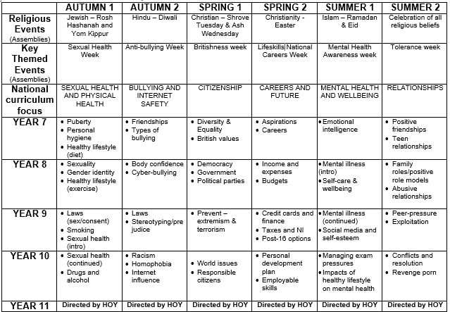

Methods of teaching and resourcing
The PSHE curriculum will be taught through a range of teaching methods, including class discussions, videos, case studies, workshops and assemblies. Many of the resources used are approved and sourced from the PSHE association.
Our PSHE education takes place during one extended tutor time per week and one assembly per fortnight. Our provision is further enriched by personal development days, whole-school events during awareness weeks and external agencies.
Assessment of PSHE
Teachers will determine pupils’ prior knowledge at the start of each topic by a formative assessment. At the end of each topic pupils will complete a summative assessment in the form of a written knowledge and skills test.
Dealing with sensitive issues
Teachers need to be sure that they are aware of issues that may arise out of teaching and learning about PSHE. The following are protocols for discussion based lessons with students:
• no one (teacher or student) will have to answer a personal question
• no one will be forced to take part in a discussion
• only the correct names for body parts will be used
• meanings of words will be explained in a sensible and factual way
• teachers may use their discretion in responding to questions and may say that the appropriate person to answer that question is the parent.
Where a member of staff is concerned that a child protection issue is arising, it is his/her responsibility to follow the school’s policy in this matter.
Visitors contributing to PSHE
Redbridge Community School works with charities and visitors from outside of the school to deliver PSHE to pupils. The school will invite local experts on issues relating to PSHE as well as use health and other professionals associated with the school. All school associate health and other professional visitors will be asked to conform to the following:
- visitors contributing to PSHE will do so at the invitation of the school and will be qualified to make an appropriate contribution
- visitors must agree with the aims of the school in delivering its policy on PSHE
- when in class, visitors will be supervised by a member of staff, who will be present at all times
- visitor will follow the school’s child protection procedures if a disclosure occurs within the classroom setting
- visitors will know and understand where their contribution fits into the school’s programme for PSHE.

